**1. Implementing Activities using Intents.**

**activity_main.xml:**

*<?*xml version="1.0" encoding="utf-8"*?>*

<androidx.constraintlayout.widget.ConstraintLayout

xmlns:android="http://schemas.android.com/apk/res/android"

xmlns:app="http://schemas.android.com/apk/res-auto"

xmlns:tools="http://schemas.android.com/tools"

android:layout_width="match_parent"

android:layout_height="match_parent"

tools:context=".MainActivity">

<EditText

android:id="@+id/name"

android:layout_width="wrap_content"

android:layout_height="wrap_content"

android:ems="10"

android:hint="Name"

android:inputType="textPersonName"

android:minHeight="48dp"

app:layout_constraintBottom_toBottomOf="parent"

app:layout_constraintEnd_toEndOf="parent"

app:layout_constraintHorizontal_bias="0.497"

app:layout_constraintStart_toStartOf="parent"

app:layout_constraintTop_toTopOf="parent"

app:layout_constraintVertical_bias="0.179"

android:importantForAutofill="no"

tools:ignore="HardcodedText" />

<Button

android:id="@+id/login"

android:layout_width="wrap_content"

android:layout_height="wrap_content"

android:text="LOGIN"

app:layout_constraintBottom_toBottomOf="parent"

app:layout_constraintEnd_toEndOf="parent"

app:layout_constraintHorizontal_bias="0.498"

app:layout_constraintStart_toStartOf="parent"

app:layout_constraintTop_toBottomOf="@+id/name"

app:layout_constraintVertical_bias="0.413"

tools:ignore="HardcodedText" />

<EditText

android:id="@+id/pwd"

android:layout_width="wrap_content"

android:layout_height="wrap_content"

android:ems="10"

android:hint="Password"

android:inputType="textPassword"

app:layout_constraintBottom_toBottomOf="parent"

app:layout_constraintEnd_toEndOf="parent"

app:layout_constraintHorizontal_bias="0.497"

app:layout_constraintStart_toStartOf="parent"

app:layout_constraintTop_toTopOf="parent"

app:layout_constraintVertical_bias="0.37"

tools:ignore="Autofill,HardcodedText,TouchTargetSizeCheck" />

</androidx.constraintlayout.widget.ConstraintLayout>

**activity_sndpg.xml:**

*<?*xml version="1.0" encoding="utf-8"*?>*

<androidx.constraintlayout.widget.ConstraintLayout

xmlns:android="http://schemas.android.com/apk/res/android"

xmlns:app="http://schemas.android.com/apk/res-auto"

xmlns:tools="http://schemas.android.com/tools"

android:layout_width="match_parent"

android:layout_height="match_parent"

tools:context=".secondpg">

<TextView

android:id="@+id/result"

android:layout_width="wrap_content"

android:layout_height="wrap_content"

android:text="@string/textview1"

android:textSize="30sp"

app:layout_constraintBottom_toBottomOf="parent"

app:layout_constraintEnd_toEndOf="parent"

app:layout_constraintHorizontal_bias="0.494"

app:layout_constraintStart_toStartOf="parent"

app:layout_constraintTop_toTopOf="parent"

app:layout_constraintVertical_bias="0.224"

android:textColor="@color/black"/>

<TextView

android:id="@+id/textView2"

android:layout_width="wrap_content"

android:layout_height="wrap_content"

android:text="Welcome!"

app:layout_constraintBottom_toBottomOf="parent"

app:layout_constraintEnd_toEndOf="parent"

app:layout_constraintHorizontal_bias="0.498"

app:layout_constraintStart_toStartOf="parent"

app:layout_constraintTop_toTopOf="parent"

app:layout_constraintVertical_bias="0.141"

android:textSize="30sp"

android:textColor="@color/black"

tools:ignore="HardcodedText" />

</androidx.constraintlayout.widget.ConstraintLayout>

**MainActivity.java:**

package com.example.login;

import android.content.Intent;

import android.os.Bundle;

import android.widget.Button;

import android.widget.EditText;

import androidx.appcompat.app.AppCompatActivity;

public class MainActivity extends AppCompatActivity {

public static final String *EXTRA_TEXT* =

"com.example.application.example.EXTRA_TEXT";

Button but;

@Override

protected void onCreate(Bundle savedInstanceState) {

super.onCreate(savedInstanceState);

setContentView(R.layout.*activity_main*);

but = findViewById(R.id.*login*);

but.setOnClickListener(v -> activity2());

}

public void activity2(){

EditText editTextName= findViewById(R.id.*name*);

String text =editTextName.getText().toString();

Intent intent = new Intent(this, secondpg.class);

intent.putExtra(*EXTRA_TEXT*,text);

startActivity(intent);

}

}

**Secondpage.java:**

package com.example.login;

import android.content.Intent;

import android.os.Bundle;

import android.widget.TextView;

import androidx.appcompat.app.AppCompatActivity;

public class secondpg extends AppCompatActivity {

@Override

protected void onCreate(Bundle savedInstanceState) {

super.onCreate(savedInstanceState);

setContentView(R.layout.*activity_secondpg*);

Intent intent= getIntent();

String text= intent.getStringExtra(com.example.login.MainActivity.*EXTRA_TEXT*);

TextView res= findViewById(R.id.*result*);

res.setText(text);

}

}

**Input screen:**

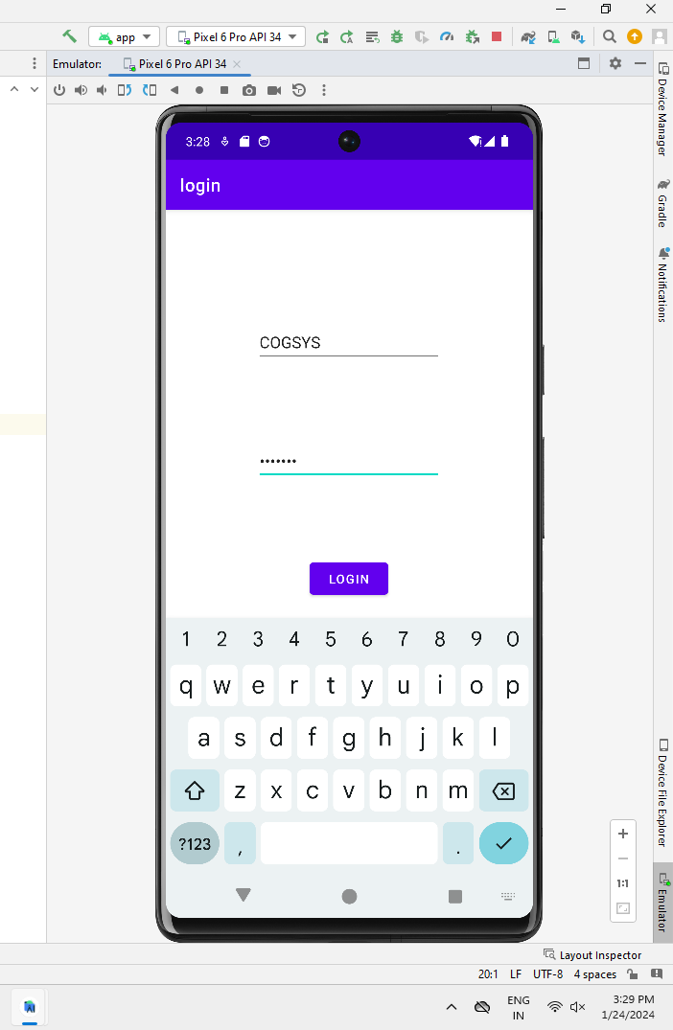

**Output screen:**

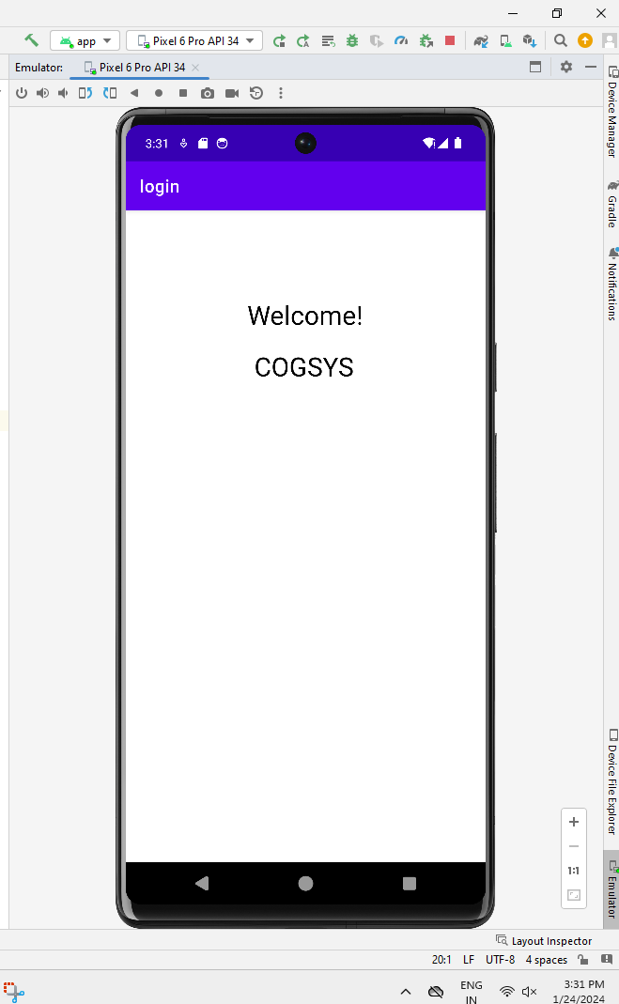

**2.Develop an Application to set an image as wallpaper and on click of a button the image should start to change randomly**

**Activity_main.xml**

*<?*xml version="1.0" encoding="utf-8"*?>*

<RelativeLayout xmlns:android="http://schemas.android.com/apk/res/android"

xmlns:tools="http://schemas.android.com/tools"

android:layout_width="match_parent"

android:layout_height="match_parent"

tools:context=".MainActivity">

<ImageView

android:id="@+id/imageView"

android:layout_width="match_parent"

android:layout_height="match_parent"

android:scaleType="centerCrop" />

<Button

android:id="@+id/changeWallpaperButton"

android:layout_width="wrap_content"

android:layout_height="wrap_content"

android:layout_centerHorizontal="true"

android:layout_alignParentBottom="true"

android:layout_marginBottom="16dp"

android:text="Change Wallpaper" />

</RelativeLayout>

**MainActivity.java:**

package com.example.activity.wallpaperchange;

import android.Manifest;

import android.annotation.SuppressLint;

import android.app.WallpaperManager;

import android.content.pm.PackageManager;

import android.os.Build;

import android.os.Bundle;

import android.view.View;

import android.widget.Button;

import android.widget.ImageView;

import androidx.annotation.NonNull;

import androidx.appcompat.app.AppCompatActivity;

import androidx.core.app.ActivityCompat;

import androidx.core.content.ContextCompat;

import com.example.activity.wallpaperchange.R;

import java.io.IOException;

import java.util.Random;

public class MainActivity extends AppCompatActivity {

private static final int *REQUEST_CODE_PERMISSION* = 123;

private ImageView imageView;

private Button changeWallpaperButton;

private int[] wallpaperImages = {

R.drawable.*wallpaper1*,

R.drawable.*wallpaper2*,

R.drawable.*wallpaper3*

*// Add more wallpaper images as needed*

};

@Override

protected void onCreate(Bundle savedInstanceState) {

super.onCreate(savedInstanceState);

setContentView(R.layout.*activity_main*);

imageView = findViewById(R.id.*imageView*);

changeWallpaperButton = findViewById(R.id.*changeWallpaperButton*);

*// Set initial wallpaper*

setRandomWallpaper();

*// Set click listener for the button*

changeWallpaperButton.setOnClickListener(new View.OnClickListener() {

@Override

public void onClick(View v) {

*// Change wallpaper on button click*

setRandomWallpaper();

}

});

*// Request permission if not granted*

requestPermission();

}

private void requestPermission() {

if (Build.VERSION.*SDK_INT* >= Build.VERSION_CODES.*M* &&

ContextCompat.*checkSelfPermission*(this, Manifest.permission.*SET_WALLPAPER*)

!= PackageManager.*PERMISSION_GRANTED*) {

ActivityCompat.*requestPermissions*(

this,

new String[]{Manifest.permission.*SET_WALLPAPER*},

*REQUEST_CODE_PERMISSION*

);

}

}

@SuppressLint("MissingSuperCall")

@Override

public void onRequestPermissionsResult(int requestCode, @NonNull String[] permissions, @NonNull int[] grantResults) {

if (requestCode == *REQUEST_CODE_PERMISSION* && grantResults.length > 0

&& grantResults[0] == PackageManager.*PERMISSION_GRANTED*) {

*// Permission granted*

}

}

private void setRandomWallpaper() {

*// Choose a random wallpaper image*

int randomIndex = new Random().nextInt(wallpaperImages.length);

int resourceId = wallpaperImages[randomIndex];

*// Set the chosen image as wallpaper*

try {

WallpaperManager.*getInstance*(this).setResource(resourceId);

} catch (IOException e) {

e.printStackTrace();

}

*// Set the chosen image in the ImageView*

imageView.setImageResource(resourceId);

}

}

**Input screen:**

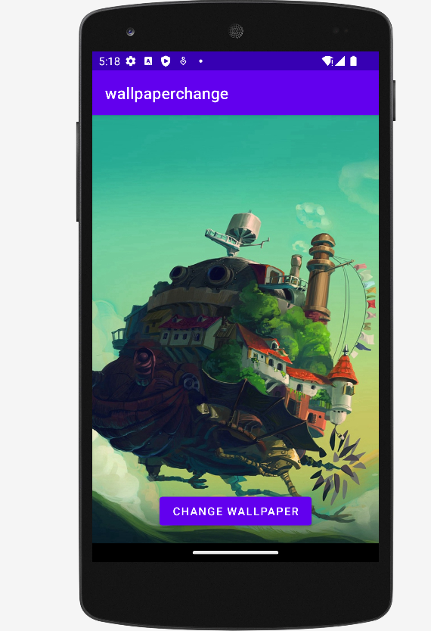

**B**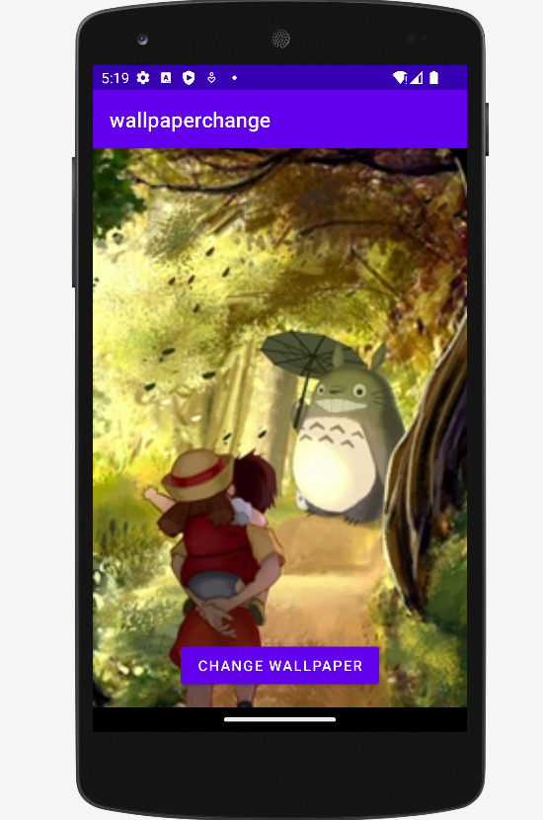

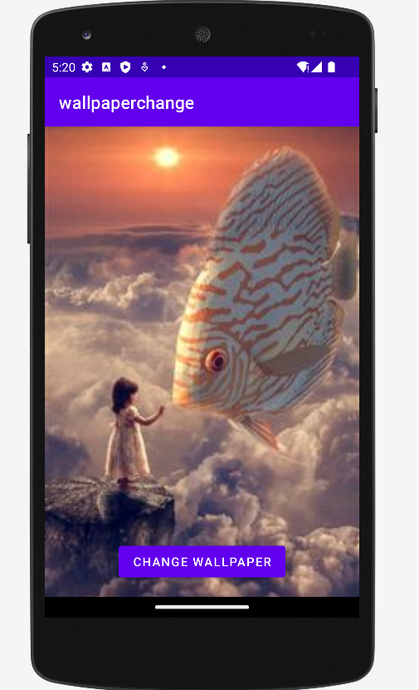

**Output screen:**

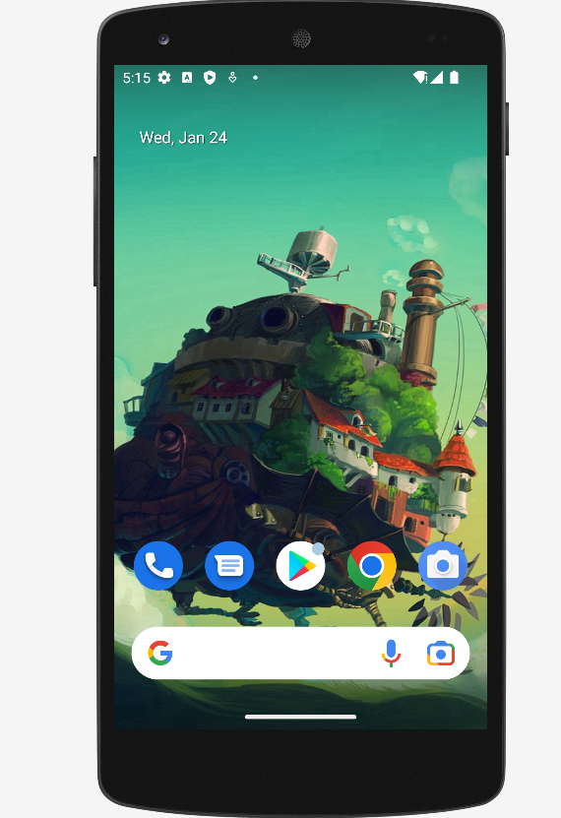

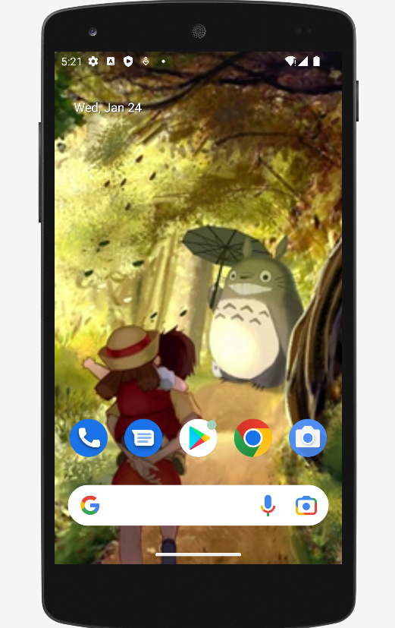

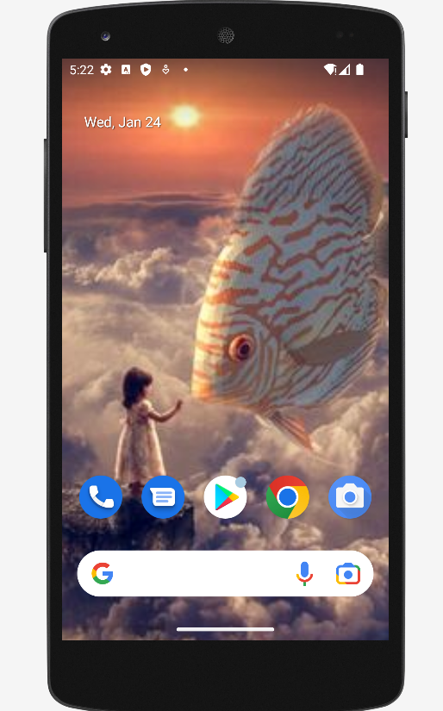

**3.Implementing UI component using various view layout**

**activity_main.xml**

*<?*xml version="1.0" encoding="utf-8"*?>*

<LinearLayout

xmlns:android="http://schemas.android.com/apk/res/android"

xmlns:tools="http://schemas.android.com/tools"

android:layout_width="match_parent"

android:layout_height="match_parent"

android:orientation="vertical"

android:padding="16dp">

<ImageView

android:id="@+id/profileImage"

android:layout_width="150dp"

android:layout_height="150dp"

android:layout_gravity="center"

android:layout_marginBottom="16dp"

android:src="@drawable/ic_launcher_foreground"

tools:ignore="ContentDescription,ImageContrastCheck" />

<EditText

android:id="@+id/editTextName"

android:layout_width="375dp"

android:layout_height="63dp"

android:layout_marginBottom="8dp"

android:hint="@string/name"

tools:ignore="TextFields"

android:importantForAutofill="no" />

<EditText

android:id="@+id/editTextEmail"

android:layout_width="379dp"

android:layout_height="59dp"

android:layout_marginBottom="16dp"

android:hint="Email"

android:inputType="textEmailAddress"

android:importantForAutofill="no"

tools:ignore="HardcodedText" />

<Button

android:id="@+id/buttonSave"

android:layout_width="289dp"

android:layout_height="wrap_content"

android:text="@string/save_changes" />

</LinearLayout>

**MainActivity.java:**

package com.example.myapplication;

import android.os.Bundle;

import android.view.View;

import android.widget.Button;

import android.widget.EditText;

import android.widget.ImageView;

import android.widget.Toast;

import android.appcompat.app.AppCompatActivity;

public class MainActivity extends AppCompatActivity {

@Override

protected void onCreate(Bundle savedInstanceState) {

super.onCreate(savedInstanceState);

setContentView(R.layout.*ttt*);

ImageView profileImage = findViewById(R.id.*profileImage*);

EditText editTextName = findViewById(R.id.*editTextName*);

EditText editTextEmail = findViewById(R.id.*editTextEmail*);

Button buttonSave = findViewById(R.id.*buttonSave*);

buttonSave.setOnClickListener(new View.OnClickListener() {

@Override

public void onClick(View view) {

String name = editTextName.getText().toString();

String email = editTextEmail.getText().toString();

*// Save logic here (you can replace this with your actual implementation)*

*// Display a toast message for demonstration purposes*

String message = "Name: " + name + "\nEmail: " + email;

Toast.*makeText*(MainActivity.this, message, Toast.*LENGTH_SHORT*).show();

}

});

}

}

**Input screen:**

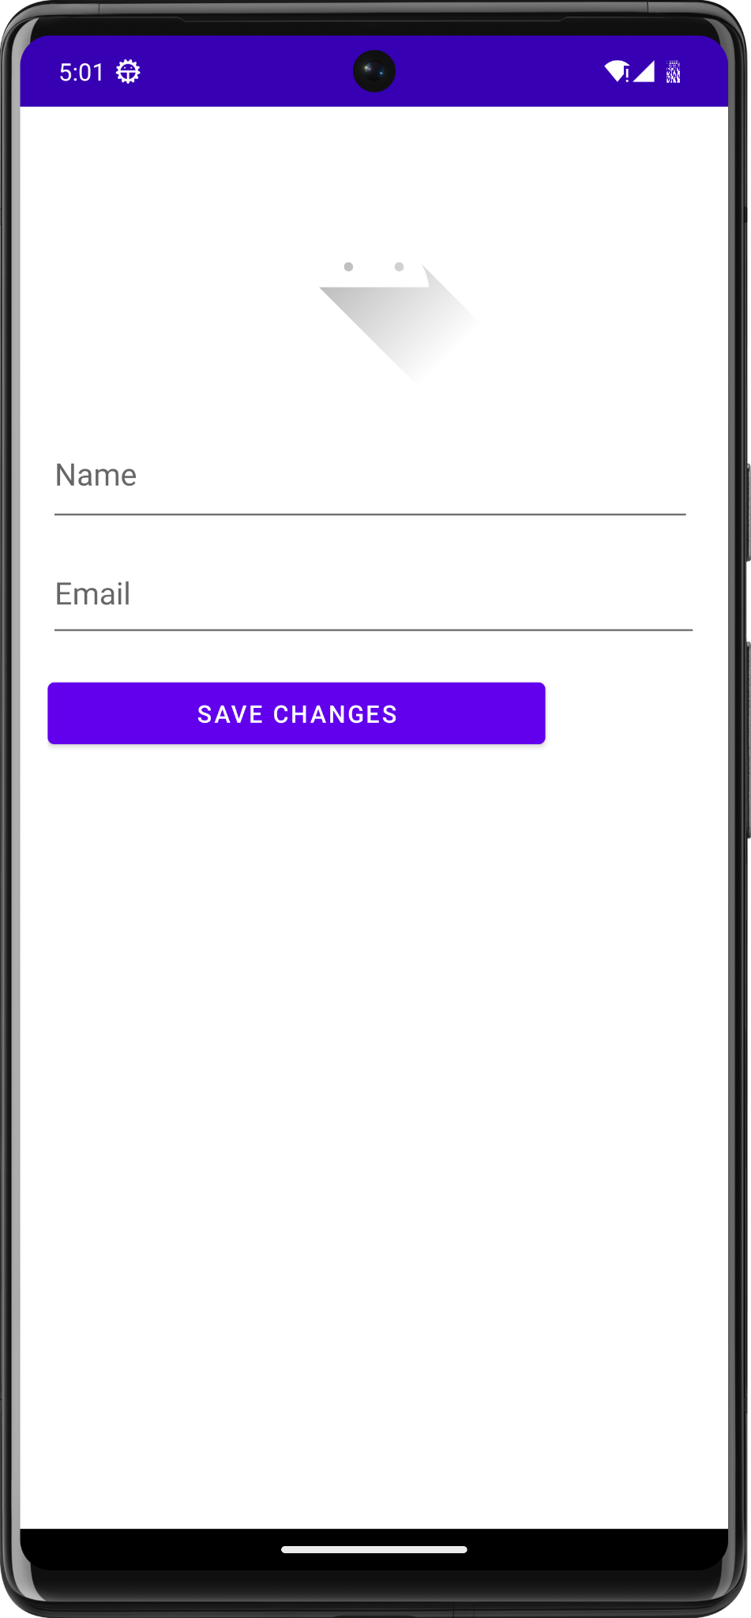

**Output screen:**

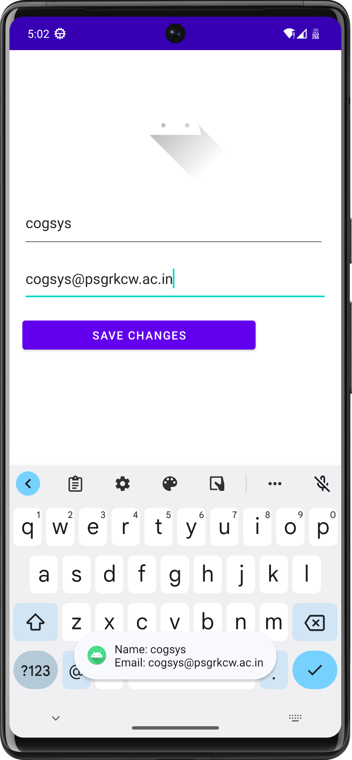

**4.Develop an android application using controls like button, textview, edittext for designing a calculator having basic functionality like addition, subtraction, multiplication and division.**

**activity_main.xml:**

*<?*xml version="1.0" encoding="utf-8"*?>*

<LinearLayout xmlns:android="http://schemas.android.com/apk/res/android"

xmlns:tools="http://schemas.android.com/tools"

android:layout_width="match_parent"

android:layout_height="match_parent"

android:orientation="vertical"

android:padding="16dp"

tools:context=".MainActivity">

<EditText

android:id="@+id/editText"

android:layout_width="match_parent"

android:layout_height="wrap_content"

android:layout_marginBottom="16dp"

android:hint="0"

android:inputType="text"

android:textSize="24sp"

tools:ignore="Autofill,DuplicateSpeakableTextCheck,HardcodedText,VisualLintTextFieldSize" />

<GridLayout

android:layout_width="match_parent"

android:layout_height="wrap_content"

android:background="@color/design_default_color_primary"

android:columnCount="4"

android:rowCount="5">

*<!-- Buttons -->*

<Button

style="?android:attr/borderlessButtonStyle"

android:onClick="onClearButtonClick"

android:text="C"

tools:ignore="HardcodedText" />

<Button

style="?android:attr/borderlessButtonStyle"

android:onClick="onOperatorClick"

android:text="+"

tools:ignore="HardcodedText" />

<Button

style="?android:attr/borderlessButtonStyle"

android:onClick="onOperatorClick"

android:text="-"

tools:ignore="HardcodedText" />

<Button

style="?android:attr/borderlessButtonStyle"

android:onClick="onOperatorClick"

android:text="*"

tools:ignore="HardcodedText" />

<Button

style="?android:attr/borderlessButtonStyle"

android:onClick="onNumberClick"

android:text="1"

tools:ignore="HardcodedText" />

<Button

style="?android:attr/borderlessButtonStyle"

android:onClick="onNumberClick"

android:text="2"

tools:ignore="HardcodedText" />

<Button

style="?android:attr/borderlessButtonStyle"

android:onClick="onNumberClick"

android:text="3"

tools:ignore="HardcodedText" />

<Button

style="?android:attr/borderlessButtonStyle"

android:onClick="onOperatorClick"

android:text="/"

tools:ignore="HardcodedText" />

<Button

style="?android:attr/borderlessButtonStyle"

android:onClick="onNumberClick"

android:text="4"

tools:ignore="HardcodedText" />

<Button

style="?android:attr/borderlessButtonStyle"

android:onClick="onNumberClick"

android:text="5"

tools:ignore="HardcodedText" />

<Button

style="?android:attr/borderlessButtonStyle"

android:onClick="onNumberClick"

android:text="6"

tools:ignore="HardcodedText" />

<Button

style="?android:attr/borderlessButtonStyle"

android:onClick="onNumberClick"

android:text="."

tools:ignore="HardcodedText" />

<Button

style="?android:attr/borderlessButtonStyle"

android:onClick="onNumberClick"

android:text="7"

tools:ignore="HardcodedText" />

<Button

style="?android:attr/borderlessButtonStyle"

android:onClick="onNumberClick"

android:text="8"

tools:ignore="HardcodedText" />

<Button

style="?android:attr/borderlessButtonStyle"

android:onClick="onNumberClick"

android:text="9"

tools:ignore="HardcodedText" />

<Button

style="?android:attr/borderlessButtonStyle"

android:onClick="onEqualButtonClick"

android:text="="

tools:ignore="DuplicateSpeakableTextCheck,HardcodedText" />

<Button

style="?android:attr/borderlessButtonStyle"

android:onClick="onNumberClick"

android:text="0"

tools:ignore="HardcodedText" />

<Button

style="?android:attr/borderlessButtonStyle"

android:layout_columnSpan="2"

android:onClick="onEqualButtonClick"

android:text="="

tools:ignore="HardcodedText" />

</GridLayout>

</LinearLayout>

**MainActivity.java:**

package com.example.activity.myapplicationcalc;

import android.annotation.SuppressLint;

import android.os.Bundle;

import android.view.View;

import android.widget.Button;

import android.widget.EditText;

import androidx.appcompat.app.AppCompatActivity;

import org.mariuszgromada.math.mxparser.Expression;

public class MainActivity extends AppCompatActivity {

private EditText editText;

@Override

protected void onCreate(Bundle savedInstanceState) {

super.onCreate(savedInstanceState);

setContentView(R.layout.*activity_main*);

editText = findViewById(R.id.*editText*);

}

public void onNumberClick(View view) {

Button button = (Button) view;

editText.append(button.getText());

}

public void onOperatorClick(View view) {

Button button = (Button) view;

editText.append(" " + button.getText() + " ");

}

public void onClearButtonClick(View view) {

editText.setText("");

}

@SuppressLint("SetTextI18n")

public void onEqualButtonClick(View view) {

String expression = editText.getText().toString();

try {

Expression expr = new Expression(expression);

double result = expr.calculate();

editText.setText(Double.*toString*(result));

} catch (Exception e) {

editText.setText("Error");

}

}

}

implementation 'org.mariuszgromada.math:MathParser.org-mXparser:4.4.2'

Add this line in build.gradle (module: app)

**Input screen:**

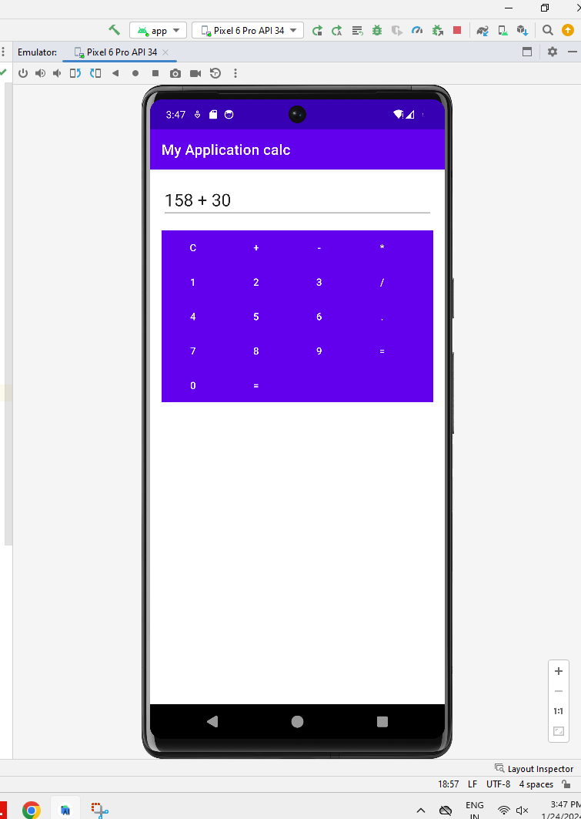

**Output screen:**

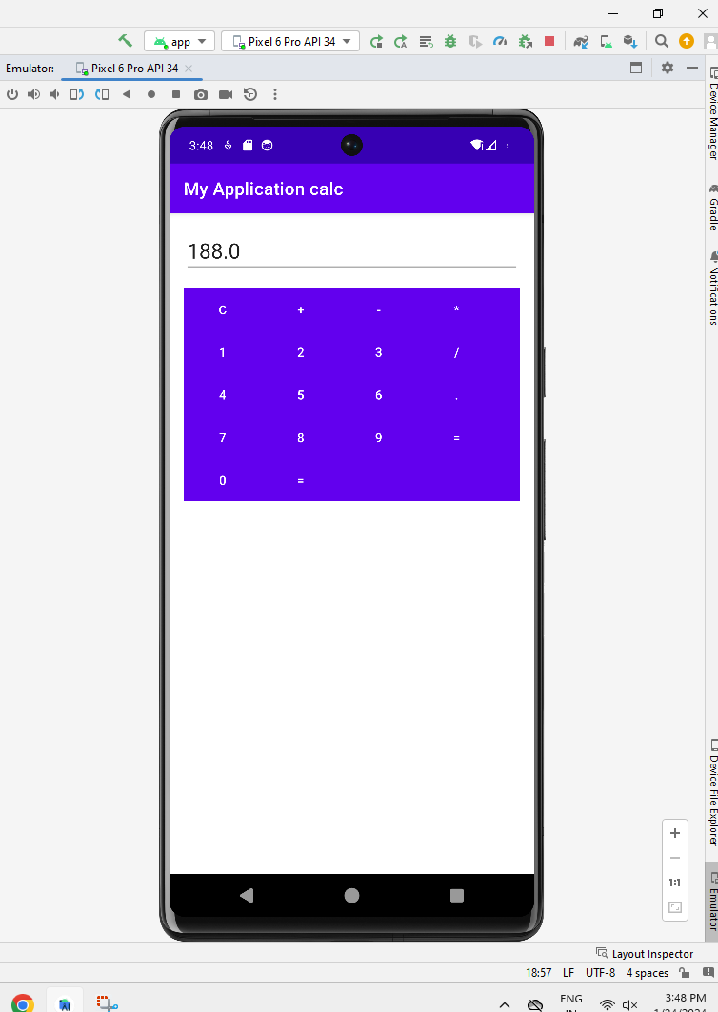

**5.Exercise using controls like Radiogroup,Button and Checkbox.**

**Layout.xml**

*<?*xml version="1.0" encoding="utf-8"*?>*

<LinearLayout xmlns:android="http://schemas.android.com/apk/res/android"

xmlns:tools="http://schemas.android.com/tools"

android:orientation="vertical"

android:layout_width="match_parent"

android:layout_height="match_parent">

<TextView

android:layout_width="match_parent"

android:layout_height="wrap_content"

android:text="select your subject"

android:textStyle="bold"

android:textSize="30dp"

tools:ignore="HardcodedText,SpUsage" />

<CheckBox

android:layout_width="match_parent"

android:layout_height="wrap_content"

android:id="@+id/tam"

android:text="Tamil"

android:textSize="25dp"

tools:ignore="HardcodedText,SpUsage">

</CheckBox>

<CheckBox

android:layout_width="match_parent"

android:layout_height="wrap_content"

android:id="@+id/eng"

android:text="English"

android:textSize="25dp"

tools:ignore="HardcodedText,SpUsage">

</CheckBox>

<CheckBox

android:id="@+id/social"

android:layout_width="match_parent"

android:layout_height="wrap_content"

android:text="Social"

android:textSize="25dp"

tools:ignore="HardcodedText,SpUsage,TextSizeCheck">

</CheckBox>

<CheckBox

android:layout_width="match_parent"

android:layout_height="wrap_content"

android:id="@+id/sci"

android:text="Science"

android:textSize="25dp"

tools:ignore="HardcodedText,SpUsage">

</CheckBox>

<TextView

android:id="@+id/gender"

android:layout_width="match_parent"

android:layout_height="wrap_content"

android:text="Select your Gender"

android:textSize="30dp"

android:textStyle="bold"

tools:ignore="HardcodedText,SpUsage" />

<RadioGroup

android:id="@+id/rgGender"

android:layout_width="match_parent"

android:layout_height="wrap_content"

android:orientation="horizontal">

<RadioButton

android:id="@+id/male"

android:layout_width="match_parent"

android:layout_height="wrap_content"

android:layout_weight="1"

android:text="Male"

android:textSize="25dp"

tools:ignore="HardcodedText,SpUsage,TextSizeCheck" />

<RadioButton

android:layout_width="match_parent"

android:layout_height="wrap_content"

android:layout_weight="1"

android:id="@+id/female"

android:text="Female"

android:textSize="25dp"

tools:ignore="HardcodedText,SpUsage" />

</RadioGroup>

<Button

android:layout_width="100dp"

android:layout_height="50dp"

android:id="@+id/subBtn"

android:text="Submit"

android:gravity="center"

android:layout_gravity="center"

tools:ignore="HardcodedText" />

</LinearLayout>

**MainActivity.java:**

package com.example.exercise5;

import androidx.appcompat.app.AppCompatActivity;

import android.annotation.SuppressLint;

import android.os.Bundle;

import android.util.Log;

import android.widget.CheckBox;

import android.widget.CompoundButton;

import android.widget.RadioButton;

import android.widget.RadioGroup;

import android.widget.Toast;

public class MainActivity extends AppCompatActivity {

String TAG=MainActivity.class.getName();

private CheckBox tam,eng,social,sci;

private RadioGroup gender;

@SuppressLint({"MissingSuperCall", "MissingInflatedId"})

@Override

protected void onCreate(Bundle savedInstanceState) {

super.onCreate(savedInstanceState);

setContentView(R.layout.*layout*);

tam=findViewById(R.id.*tam*);

eng=findViewById(R.id.*eng*);

social=findViewById(R.id.*social*);

sci=findViewById(R.id.*sci*);

tam.setOnCheckedChangeListener(new CompoundButton.OnCheckedChangeListener() {

@Override

public void onCheckedChanged(CompoundButton compoundButton, boolean b) {

Log.*d*(TAG,tam.getText().toString()+"status"+b);

Toast.*makeText*(getApplicationContext(),tam.getText().toString()+" "+b,Toast.*LENGTH_LONG*).show();

}

});

eng.setOnCheckedChangeListener(new CompoundButton.OnCheckedChangeListener() {

@Override

public void onCheckedChanged(CompoundButton compoundButton, boolean b) {

Log.*d*(TAG,eng.getText().toString()+"status"+b);

Toast.*makeText*(getApplicationContext(),eng.getText().toString()+" "+b,Toast.*LENGTH_LONG*).show();

}

});

gender=findViewById(R.id.*rgGender*);

gender.setOnCheckedChangeListener((radioGroup, i) -> {

RadioButton radioButton=gender.findViewById(i);

String selectedstr=radioButton.getText().toString();

Toast.*makeText*(MainActivity.this, "Yourselection is"+selectedstr,Toast.*LENGTH_LONG*).show();});

}

}

**Input screen:**

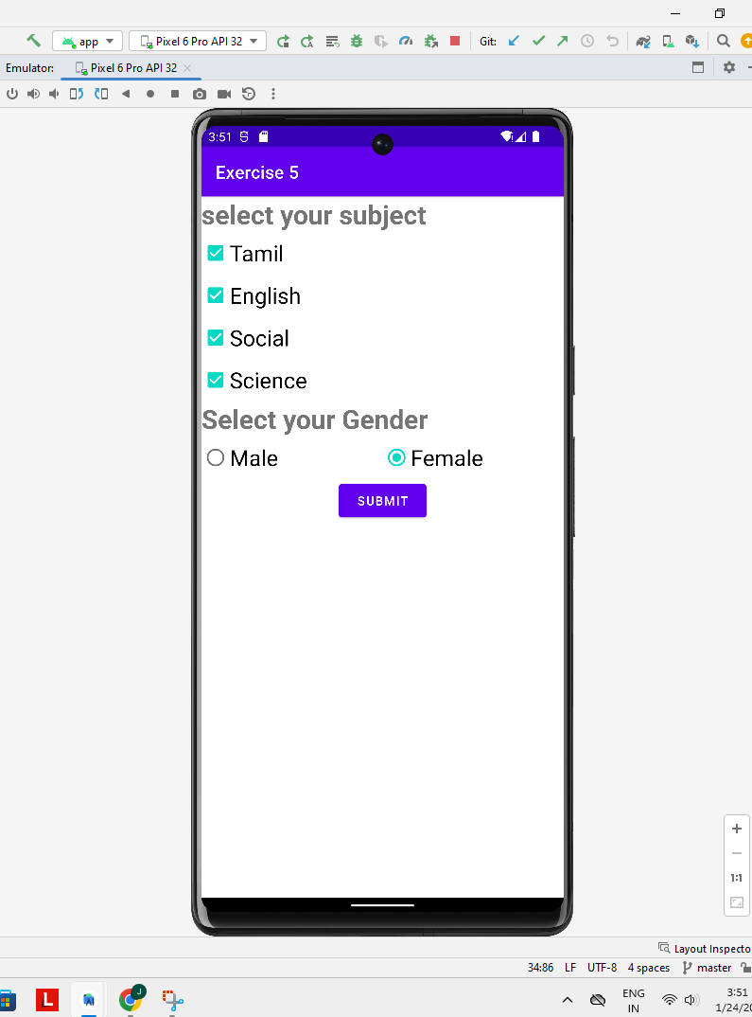

**Output screen:**

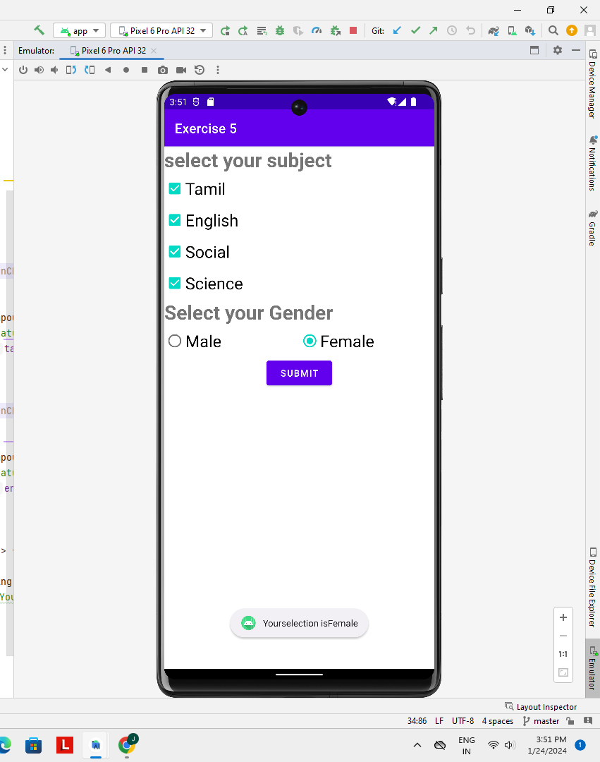

**6.Exercise using ProgressBar view and spinner View**

**activity_main.xml:**

*<?*xml version="1.0" encoding="utf-8"*?>*

<RelativeLayout xmlns:android="http://schemas.android.com/apk/res/android"

xmlns:tools="http://schemas.android.com/tools"

android:layout_width="match_parent"

android:layout_height="match_parent"

android:paddingLeft="16dp"

android:paddingTop="16dp"

android:paddingRight="16dp"

android:paddingBottom="16dp"

tools:context=".MainActivity">

<ProgressBar

android:id="@+id/progressBar"

style="?android:attr/progressBarStyleHorizontal"

android:layout_width="match_parent"

android:layout_height="wrap_content"

android:layout_centerVertical="true"

android:layout_marginTop="20dp"/>

<Spinner

android:id="@+id/spinner"

android:layout_width="match_parent"

android:layout_height="wrap_content"

android:layout_below="@id/progressBar"

android:layout_marginTop="20dp"/>

</RelativeLayout>

**MainActivity.java:**

package com.example.record6;

import android.os.Bundle;

import android.view.View;

import android.widget.AdapterView;

import android.widget.ArrayAdapter;

import android.widget.ProgressBar;

import android.widget.Spinner;

import androidx.appcompat.app.AppCompatActivity;

import com.example.record6.R;

public class MainActivity extends AppCompatActivity {

private ProgressBar progressBar;

private Spinner spinner;

@Override

protected void onCreate(Bundle savedInstanceState) {

super.onCreate(savedInstanceState);

setContentView(R.layout.*activity_main*);

*// Initialize views*

progressBar = findViewById(R.id.*progressBar*);

spinner = findViewById(R.id.*spinner*);

*// Set up spinner with sample data*

String[] spinnerItems = {"Level 1", "Level 2", "Level 3", "Level 4", "Level 5"};

ArrayAdapter<String> adapter = new ArrayAdapter<>(this, android.R.layout.*simple_spinner_dropdown_item*, spinnerItems);

spinner.setAdapter(adapter);

*// Set a listener for spinner item selection*

spinner.setOnItemSelectedListener(new AdapterView.OnItemSelectedListener() {

@Override

public void onItemSelected(AdapterView<?> parentView, View selectedItemView, int position, long id) {

*// Update progress bar based on the selected item*

int progress = (position + 1) * 20;

progressBar.setProgress(progress);

}

@Override

public void onNothingSelected(AdapterView<?> parentView) {

*// Do nothing here*

}

});

}

}

**Input screen:**

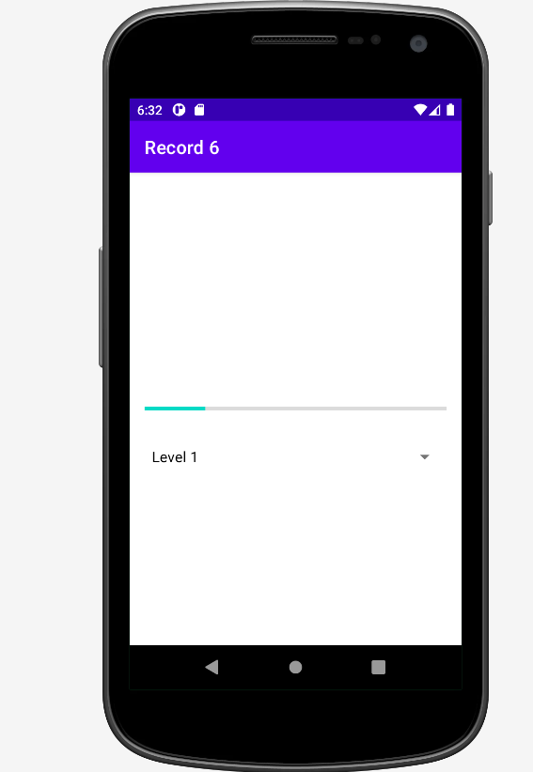

**Output screen:**

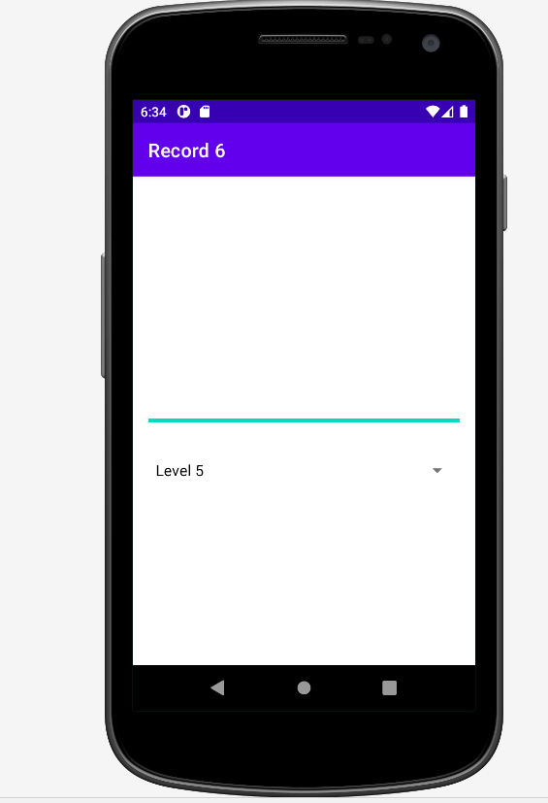

**7. Exercise using ImageView and TextView.**

**activity_main.xml:**

*<?*xml version="1.0" encoding="utf-8"*?>*

<RelativeLayout xmlns:android="http://schemas.android.com/apk/res/android"

xmlns:tools="http://schemas.android.com/tools"

android:layout_width="match_parent"

android:layout_height="match_parent"

android:background="@color/teal_200"

tools:context=".MainActivity">

*<!-- ImageView to display an image -->*

<ImageView

android:id="@+id/myImageView"

android:layout_width="200dp"

android:layout_height="200dp"

android:layout_alignParentTop="true"

android:layout_centerHorizontal="true"

android:layout_marginTop="50dp"

android:src="@drawable/img1" />

*<!-- TextView to display text -->*

<TextView

android:id="@+id/myTextView"

android:layout_width="wrap_content"

android:layout_height="wrap_content"

android:layout_below="@id/myImageView"

android:layout_alignParentStart="true"

android:layout_alignParentEnd="true"

android:layout_alignParentBottom="true"

android:layout_marginStart="20dp"

android:layout_marginTop="103dp"

android:layout_marginEnd="15dp"

android:layout_marginBottom="342dp"

android:text="WELCOME TO ANDROID STUDIO !"

android:textColor="@color/black"

android:textSize="25sp" />

</RelativeLayout>

**MainActivity.java:**

package com.example.textviewandimage;

import androidx.appcompat.app.AppCompatActivity;

import android.os.Bundle;

import com.example.textviewandimage.R;

public class MainActivity extends AppCompatActivity {

@Override

protected void onCreate(Bundle savedInstanceState) {

super.onCreate(savedInstanceState);

setContentView(R.layout.*activity_main*);

}

**OUTPUT SCREEN::**

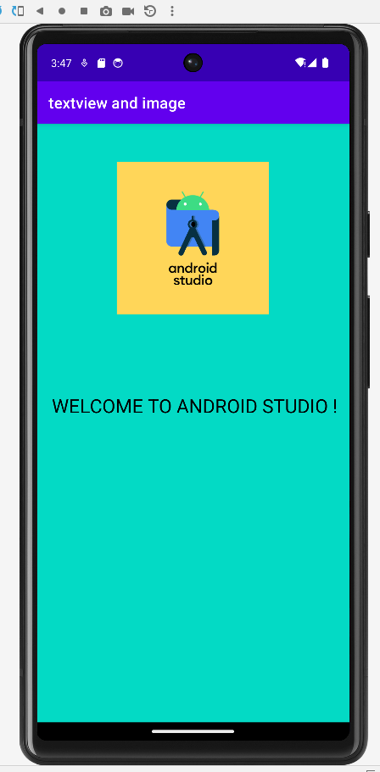

**8. Develop an application in android that makes use of notification manager.**

**Activity_main.xml:**

*<?*xml version="1.0" encoding="utf-8"*?>*

<RelativeLayout xmlns:android="http://schemas.android.com/apk/res/android"

xmlns:tools="http://schemas.android.com/tools"

android:layout_width="match_parent"

android:layout_height="match_parent"

android:padding="16dp"

tools:context=".MainActivity">

<Button

android:layout_width="wrap_content"

android:layout_height="wrap_content"

android:layout_centerInParent="true"

android:text="Send Notification"

android:onClick="sendNotification"/>

</RelativeLayout>

**MainActivity.java:**

package com.example.program8;

import android.app.NotificationChannel;

import android.app.NotificationManager;

import android.content.Context;

import android.os.Build;

import android.os.Bundle;

import android.view.View;

import androidx.appcompat.app.AppCompatActivity;

import androidx.core.app.NotificationCompat;

import com.example.program8.R;

public class MainActivity extends AppCompatActivity {

private static final String *CHANNEL_ID* = "my_channel";

private static final CharSequence *CHANNEL_NAME* = "My Channel";

private static final String *CHANNEL_DESCRIPTION* = "This is my notification channel";

@Override

protected void onCreate(Bundle savedInstanceState) {

super.onCreate(savedInstanceState);

setContentView(R.layout.*activity_main*);

createNotificationChannel();

}

private void createNotificationChannel() {

if (Build.VERSION.*SDK_INT* >= Build.VERSION_CODES.*O*) {

NotificationChannel channel = new NotificationChannel(

*CHANNEL_ID*,

*CHANNEL_NAME*,

NotificationManager.*IMPORTANCE_DEFAULT*);

channel.setDescription(*CHANNEL_DESCRIPTION*);

NotificationManager notificationManager = getSystemService(NotificationManager.class);

notificationManager.createNotificationChannel(channel);

}

}

public void sendNotification(View view) {

NotificationCompat.Builder builder = new NotificationCompat.Builder(this, *CHANNEL_ID*)

.setSmallIcon(R.drawable.*ic_notification*)

.setContentTitle("My Notification")

.setContentText("This is a notification from my app")

.setPriority(NotificationCompat.*PRIORITY_DEFAULT*);

NotificationManager notificationManager = (NotificationManager) getSystemService(Context.*NOTIFICATION_SERVICE*);

notificationManager.notify(1, builder.build());

}

}

**Output:**

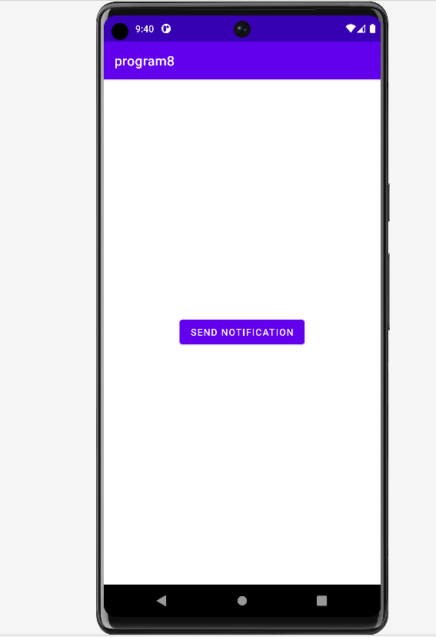

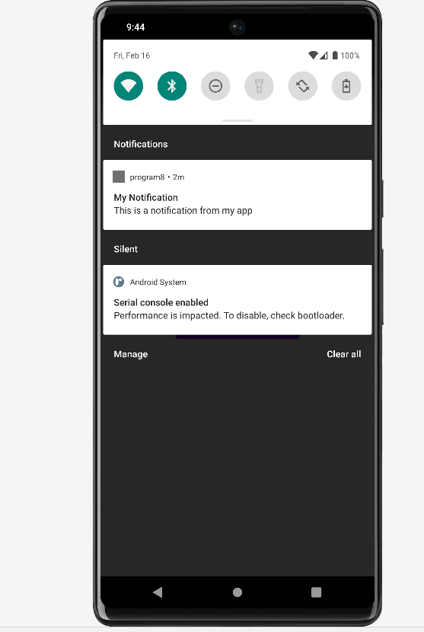

**9. Create a Stopwatch application using android studio.**

**Activity_main.xml:**

*<?*xml version="1.0" encoding="utf-8"*?>*

<LinearLayout xmlns:android="http://schemas.android.com/apk/res/android"

xmlns:app="http://schemas.android.com/apk/res-auto"

xmlns:tools="http://schemas.android.com/tools"

android:layout_width="match_parent"

android:layout_height="match_parent"

android:layout_gravity="center"

android:gravity="center"

android:orientation="vertical"

tools:context=".MultiTaskActivity">

<Button

android:id="@+id/txtStopWatch"

android:layout_width="wrap_content"

android:layout_height="wrap_content"

android:layout_marginTop="?actionBarSize"

android:text="Stop Watch"

app:layout_constraintEnd_toEndOf="parent"

app:layout_constraintStart_toStartOf="parent"

app:layout_constraintTop_toTopOf="parent" />

</LinearLayout>

**Activity_stopwatch.xml:**

*<?*xml version="1.0" encoding="utf-8"*?>*

<LinearLayout xmlns:android="http://schemas.android.com/apk/res/android"

android:layout_width="match_parent"

android:layout_height="match_parent"

android:background="#0F9D58"

android:layout_gravity="center"

android:gravity="center"

android:orientation="vertical"

android:padding="16dp">

<TextView

android:id="@+id/time_view"

android:layout_width="wrap_content"

android:layout_height="wrap_content"

android:layout_gravity="center_horizontal"

android:textAppearance="@android:style/TextAppearance.Large"

android:textSize="56sp" />

<Button

android:id="@+id/start_button"

android:layout_width="wrap_content"

android:layout_height="wrap_content"

android:layout_gravity="center_horizontal"

android:layout_marginTop="20dp"

android:onClick="onClickStart"

android:text="Start" />

<Button

android:id="@+id/stop_button"

android:layout_width="wrap_content"

android:layout_height="wrap_content"

android:layout_gravity="center_horizontal"

android:layout_marginTop="8dp"

android:onClick="onClickStop"

android:text="Stop" />

<Button

android:id="@+id/reset_button"

android:layout_width="wrap_content"

android:layout_height="wrap_content"

android:layout_gravity="center_horizontal"

android:layout_marginTop="8dp"

android:onClick="onClickReset"

android:text="Reset" />

</LinearLayout>

**StopWatchActivity.java:**

package com.example.activity.myapplication;

import android.content.Intent;

import android.os.Bundle;

import android.os.Handler;

import android.view.View;

import android.widget.Button;

import android.widget.TextView;

import androidx.annotation.Nullable;

import androidx.appcompat.app.AppCompatActivity;

import java.util.Locale;

public class StopwatchActivity extends AppCompatActivity {

private int seconds = 0;

*// Is the stopwatch running?*

private boolean running;

private boolean wasRunning;

@Override

protected void onCreate(@Nullable Bundle savedInstanceState) {

super.onCreate(savedInstanceState);

setContentView(R.layout.*activity_stopwatch*);

if (savedInstanceState != null) {

*// Get the previous state of the stopwatch*

*// if the activity has been*

*// destroyed and recreated.*

seconds = savedInstanceState.getInt("seconds");

running = savedInstanceState.getBoolean("running");

wasRunning = savedInstanceState.getBoolean("wasRunning");

}

runTimer();

}

private void runTimer() {

final TextView timeView = (TextView) findViewById(R.id.*time_view*);

Handler handler = new Handler();

handler.post(new Runnable() {

@Override

public void run() {

int hours = seconds / 3600; *//3600=1 hr*

int minutes = (seconds % 3600) / 60;

int secs = seconds % 60;

String time = String.*format*(Locale.*getDefault*(), "%d:%02d:%02d", hours,

minutes, secs);

timeView.setText(time);

if (running) {

seconds++;

}

*// Post the code again*

*// with a delay of 1 second.*

handler.postDelayed(this, 1000);

}

});

}

@Override

public void onSaveInstanceState(Bundle savedInstanceState) {

super.onSaveInstanceState(savedInstanceState);

savedInstanceState.putInt("seconds", seconds);

savedInstanceState.putBoolean("running", running);

savedInstanceState.putBoolean("wasRunning", wasRunning);

}

@Override

protected void onPause() {

super.onPause();

wasRunning = running;

running = false;

}

*// If the activity is resumed,*

*// start the stopwatch*

*// again if it was running previously.*

@Override

protected void onResume() {

super.onResume();

if (wasRunning) {

running = true;

}

}

*// Start the stopwatch running*

*// when the Start button is clicked.*

*// Below method gets called*

*// when the Start button is clicked.*

public void onClickStart(View view) {

running = true;

}

*// Stop the stopwatch running*

*// when the Stop button is clicked.*

*// Below method gets called*

*// when the Stop button is clicked.*

public void onClickStop(View view) {

running = false;

}

*// Reset the stopwatch when*

*// the Reset button is clicked.*

*// Below method gets called*

*// when the Reset button is clicked.*

public void onClickReset(View view) {

running = false;

seconds = 0;

}

}

**MainActivity.java:**

package com.example.activity.myapplication;

import android.content.Intent;

import android.os.Bundle;

import android.os.Handler;

import android.view.View;

import android.widget.Button;

import android.widget.TextView;

import androidx.annotation.Nullable;

import androidx.appcompat.app.AppCompatActivity;

import java.util.Locale;

public class StopwatchActivity extends AppCompatActivity {

private int seconds = 0;

*// Is the stopwatch running?*

private boolean running;

private boolean wasRunning;

@Override

protected void onCreate(@Nullable Bundle savedInstanceState) {

super.onCreate(savedInstanceState);

setContentView(R.layout.*activity_stopwatch*);

if (savedInstanceState != null) {

*// Get the previous state of the stopwatch*

*// if the activity has been*

*// destroyed and recreated.*

seconds = savedInstanceState.getInt("seconds");

running = savedInstanceState.getBoolean("running");

wasRunning = savedInstanceState.getBoolean("wasRunning");

}

runTimer();

}

private void runTimer() {

final TextView timeView = (TextView) findViewById(R.id.*time_view*);

Handler handler = new Handler();

handler.post(new Runnable() {

@Override

public void run() {

int hours = seconds / 3600; *//3600=1 hr*

int minutes = (seconds % 3600) / 60;

int secs = seconds % 60;

String time = String.*format*(Locale.*getDefault*(), "%d:%02d:%02d", hours,

minutes, secs);

timeView.setText(time);

if (running) {

seconds++;

}

*// Post the code again*

*// with a delay of 1 second.*

handler.postDelayed(this, 1000);

}

});

}

@Override

public void onSaveInstanceState(Bundle savedInstanceState) {

super.onSaveInstanceState(savedInstanceState);

savedInstanceState.putInt("seconds", seconds);

savedInstanceState.putBoolean("running", running);

savedInstanceState.putBoolean("wasRunning", wasRunning);

}

@Override

protected void onPause() {

super.onPause();

wasRunning = running;

running = false;

}

*// If the activity is resumed,*

*// start the stopwatch*

*// again if it was running previously.*

@Override

protected void onResume() {

super.onResume();

if (wasRunning) {

running = true;

}

}

*// Start the stopwatch running*

*// when the Start button is clicked.*

*// Below method gets called*

*// when the Start button is clicked.*

public void onClickStart(View view) {

running = true;

}

*// Stop the stopwatch running*

*// when the Stop button is clicked.*

*// Below method gets called*

*// when the Stop button is clicked.*

public void onClickStop(View view) {

running = false;

}

*// Reset the stopwatch when*

*// the Reset button is clicked.*

*// Below method gets called*

*// when the Reset button is clicked.*

public void onClickReset(View view) {

running = false;

seconds = 0;

}

}

**Output:**

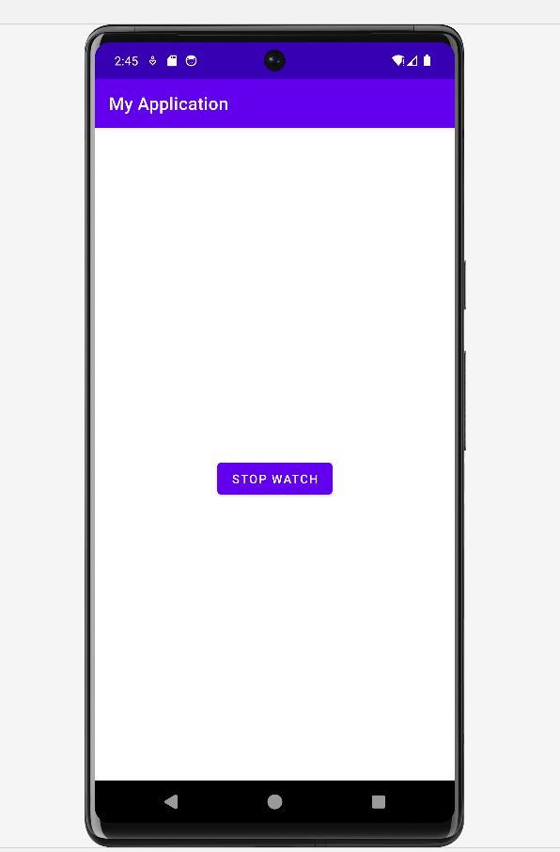

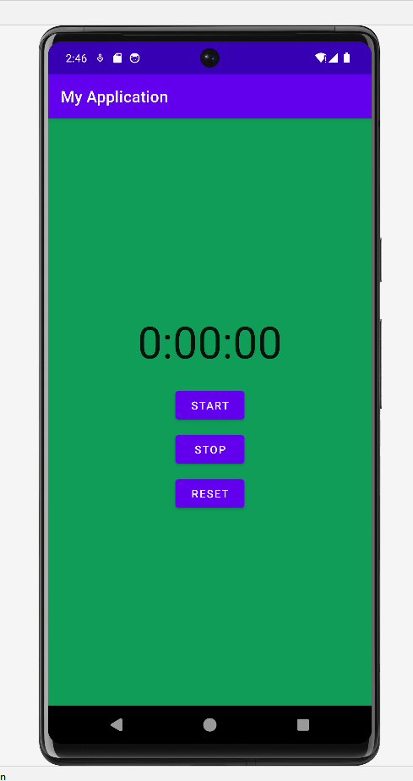

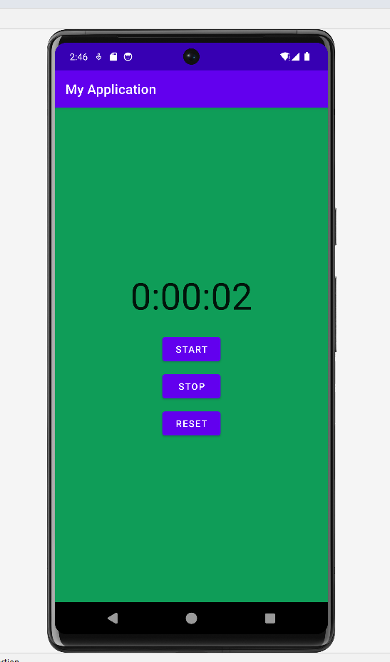

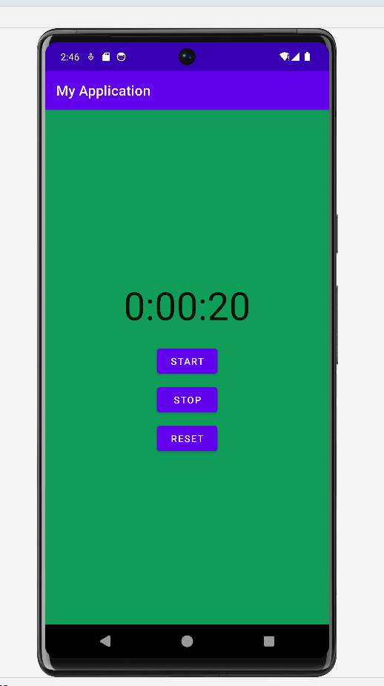

**10. Exercise using Action bar, menus and adding menu items.**

**Activity_main.xml:**

*<?*xml version="1.0" encoding="utf-8"*?>*

<RelativeLayout xmlns:android="http://schemas.android.com/apk/res/android"

xmlns:app="http://schemas.android.com/apk/res-auto"

xmlns:tools="http://schemas.android.com/tools"

android:layout_width="match_parent"

android:layout_height="match_parent"

tools:context=".MainActivity">

<androidx.appcompat.widget.Toolbar

android:id="@+id/toolbar"

android:layout_width="match_parent"

android:layout_height="?attr/actionBarSize"

android:background="?attr/colorPrimary"/>

<androidx.constraintlayout.widget.ConstraintLayout

android:layout_width="match_parent"

android:layout_height="match_parent">

<TextView

android:id="@+id/textView2"

android:layout_width="wrap_content"

android:layout_height="wrap_content"

android:layout_marginBottom="348dp"

android:foregroundTint="#E33C3C"

android:text="ACTION BAR AND MENU ITEMS"

android:textColor="#14ACF1"

android:textSize="24sp"

app:layout_constraintBottom_toBottomOf="parent"

app:layout_constraintEnd_toEndOf="parent"

app:layout_constraintHorizontal_bias="0.492"

app:layout_constraintStart_toStartOf="parent" />

</androidx.constraintlayout.widget.ConstraintLayout>

</RelativeLayout>

**main_menu.xml:**

*<?*xml version="1.0" encoding="utf-8"*?>*

<menu xmlns:android="http://schemas.android.com/apk/res/android"

xmlns:app="http://schemas.android.com/apk/res-auto">

<item

android:id="@+id/action_devicecare"

android:title="Device care"

app:showAsAction="never"/>

<item

android:id="@+id/action_themes"

android:title="Themes"

app:showAsAction="never"/>

<item

android:id="@+id/action_settings"

android:title="Settings"

app:showAsAction="never"/>

</menu>

**MainActivity.java:**

package com.example.activity.ex10;

import android.os.Bundle;

import android.view.Menu;

import android.view.MenuInflater;

import android.view.MenuItem;

import android.widget.Toast;

import androidx.appcompat.app.AppCompatActivity;

import androidx.appcompat.widget.Toolbar;

public class MainActivity extends AppCompatActivity {

@Override

protected void onCreate(Bundle savedInstanceState) {

super.onCreate(savedInstanceState);

setContentView(R.layout.*activity_main*);

Toolbar toolbar = findViewById(R.id.*toolbar*);

setSupportActionBar(toolbar);

}

@Override

public boolean onCreateOptionsMenu(Menu menu) {

MenuInflater inflater = getMenuInflater();

inflater.inflate(R.menu.*main_menu*, menu);

return true;

}

@Override

public boolean onOptionsItemSelected(MenuItem item) {

*// Handle item selection*

switch (item.getItemId()) {

case R.id.*action_devicecare*:

showToast("Device care selected");

return true;

case R.id.*action_themes*:

showToast("Themes selected");

return true;

case R.id.*action_settings*:

showToast("Settings selected");

return true;

default:

return super.onOptionsItemSelected(item);

}

}

private void showToast(String message) {

Toast.*makeText*(this, message, Toast.*LENGTH_SHORT*).show();

}

}

**Output:**

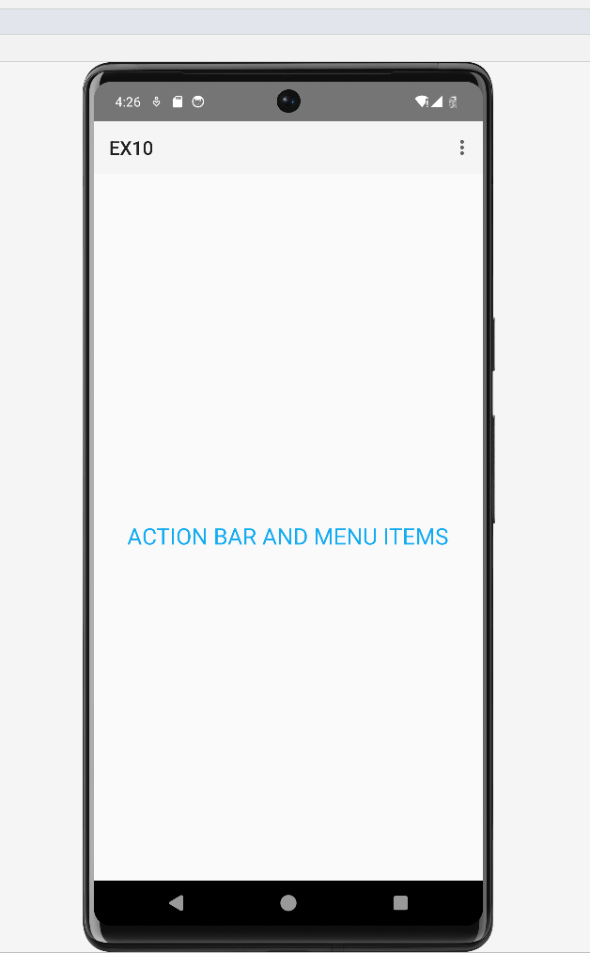

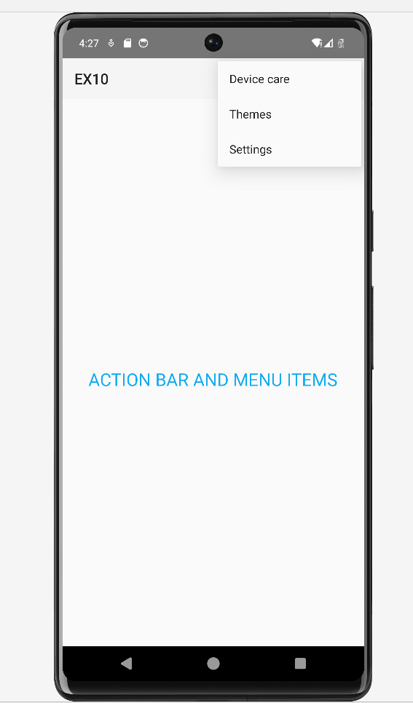

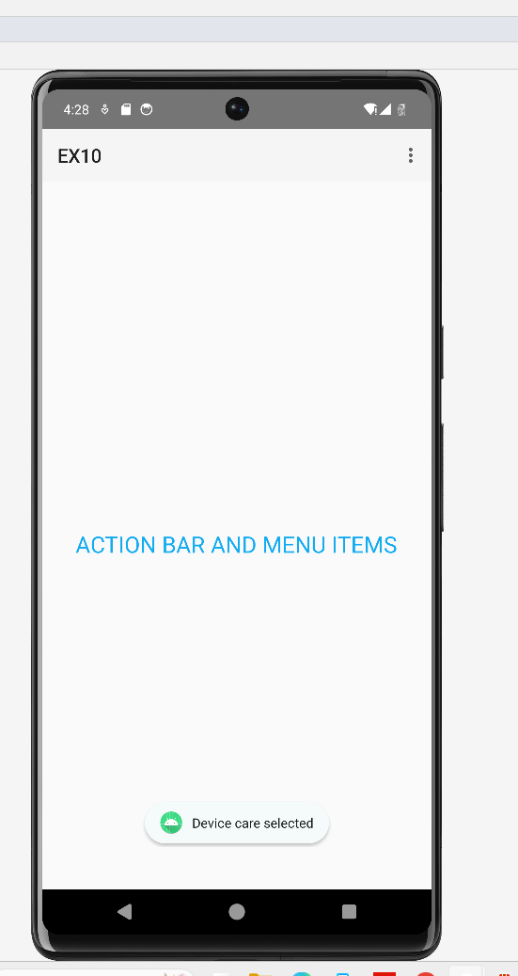

**11.Exercise using saving and loading user preferences.**

**Activity_main.xml:**

<RelativeLayout xmlns:android="http://schemas.android.com/apk/res/android"

xmlns:tools="http://schemas.android.com/tools"

android:layout_width="match_parent"

android:layout_height="match_parent"

android:padding="16dp"

tools:context=".MainActivity">

<TextView

android:id="@+id/tv_language"

android:layout_width="wrap_content"

android:layout_height="wrap_content"

android:text="Preferred Language:"

android:textSize="18sp"

android:layout_marginTop="16dp" />

<Spinner

android:id="@+id/spinner_language"

android:layout_width="wrap_content"

android:layout_height="wrap_content"

android:layout_below="@id/tv_language"

android:layout_marginTop="8dp" />

<TextView

android:id="@+id/tv_font_size"

android:layout_width="wrap_content"

android:layout_height="wrap_content"

android:text="Preferred Font Size:"

android:textSize="18sp"

android:layout_below="@id/spinner_language"

android:layout_marginTop="16dp" />

<SeekBar

android:id="@+id/seekBar_font_size"

android:layout_width="match_parent"

android:layout_height="wrap_content"

android:layout_below="@id/tv_font_size"

android:layout_marginTop="8dp"

android:max="30"

android:progress="18" />

<Button

android:id="@+id/btn_save"

android:layout_width="wrap_content"

android:layout_height="wrap_content"

android:text="Save Preferences"

android:layout_below="@id/seekBar_font_size"

android:layout_centerHorizontal="true"

android:layout_marginTop="24dp" />

</RelativeLayout>

**arrays.xml:**

<resources>

<string-array name="languages_array">

<item>English</item>

<item>Spanish</item>

<item>French</item>

<item>German</item>

<item>Chinese</item>

</string-array>

</resources>

**MainActivity.java:**

package com.example.activity.program10;

import android.content.SharedPreferences;

import android.os.Bundle;

import android.widget.ArrayAdapter;

import android.widget.Button;

import android.widget.SeekBar;

import android.widget.Spinner;

import android.widget.Toast;

import androidx.appcompat.app.AppCompatActivity;

public class MainActivity extends AppCompatActivity {

private Spinner spinnerLanguage;

private SeekBar seekBarFontSize;

private Button btnSave;

private SharedPreferences preferences;

private static final String *PREF_NAME* = "user_preferences";

private static final String *KEY_LANGUAGE* = "preferred_language";

private static final String *KEY_FONT_SIZE* = "preferred_font_size";

@Override

protected void onCreate(Bundle savedInstanceState) {

super.onCreate(savedInstanceState);

setContentView(R.layout.*activity_main*);

spinnerLanguage = findViewById(R.id.*spinner_language*);

seekBarFontSize = findViewById(R.id.*seekBar_font_size*);

btnSave = findViewById(R.id.*btn_save*);

*// Set up spinner with language options*

ArrayAdapter<CharSequence> adapter = ArrayAdapter.*createFromResource*(this,

R.array.*languages_array*, android.R.layout.*simple_spinner_item*);

adapter.setDropDownViewResource(android.R.layout.*simple_spinner_dropdown_item*);

spinnerLanguage.setAdapter(adapter);

preferences = getSharedPreferences(*PREF_NAME*, *MODE_PRIVATE*);

*// Load preferences*

loadPreferences();

btnSave.setOnClickListener(v -> savePreferences());

}

private void loadPreferences() {

String language = preferences.getString(*KEY_LANGUAGE*, "");

int fontSize = preferences.getInt(*KEY_FONT_SIZE*, 18);

*// Set saved preferences*

spinnerLanguage.setSelection(getIndex(spinnerLanguage, language));

seekBarFontSize.setProgress(fontSize);

}

private void savePreferences() {

String selectedLanguage = spinnerLanguage.getSelectedItem().toString();

int selectedFontSize = seekBarFontSize.getProgress();

*// Save preferences*

SharedPreferences.Editor editor = preferences.edit();

editor.putString(*KEY_LANGUAGE*, selectedLanguage);

editor.putInt(*KEY_FONT_SIZE*, selectedFontSize);

editor.apply();

Toast.*makeText*(this, "Preferences saved successfully", Toast.*LENGTH_SHORT*).show();

}

private int getIndex(Spinner spinner, String value) {

for (int i = 0; i < spinner.getCount(); i++) {

if (spinner.getItemAtPosition(i).toString().equalsIgnoreCase(value)) {

return i;

}

}

return 0;

}

}

**Output:**

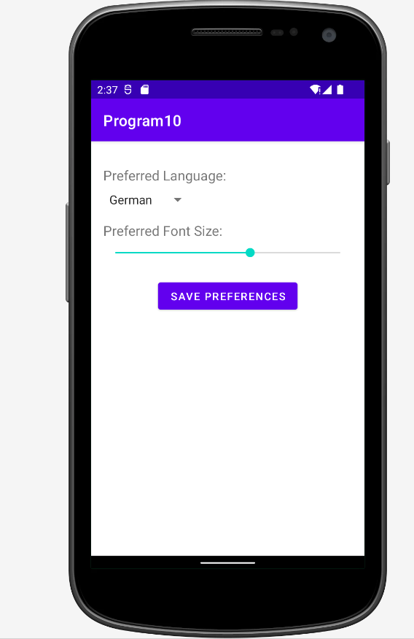

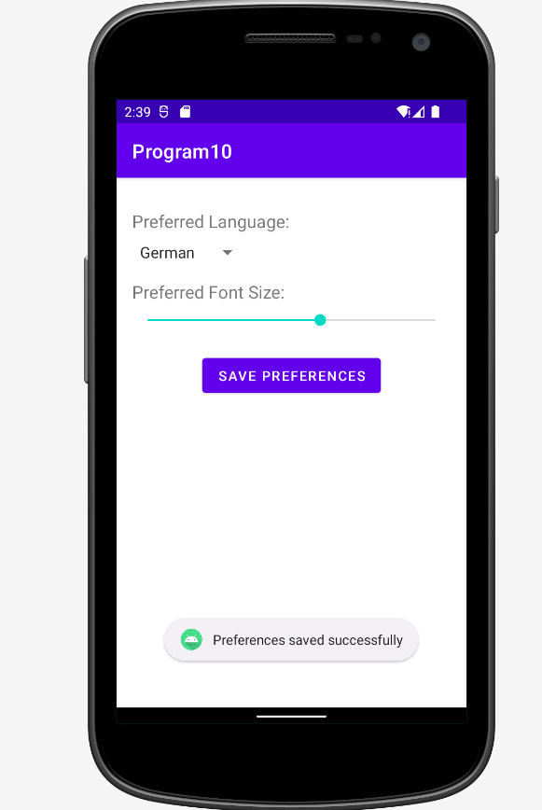

**12. Create SQLite database using dbadapter helper**

**Code:**

**Activity_main.xml:**

<?xml version="1.0" encoding="utf-8"?>

<LinearLayout xmlns:android="http://schemas.android.com/apk/res/android"

xmlns:app="http://schemas.android.com/apk/res-auto"

xmlns:tools="http://schemas.android.com/tools"

android:layout_width="match_parent"

android:layout_height="match_parent"

android:orientation="vertical"

tools:context=".MainActivity">

<TextView

android:layout_width="match_parent"

android:layout_height="wrap_content"

android:text="Enter Name"

android:textSize="30dp"/>

<EditText

android:id="@+id/edttxtname"

android:layout_width="match_parent"

android:layout_height="wrap_content"

android:textSize="30dp"

tools:ignore="SpeakableTextPresentCheck" />

<TextView

android:layout_width="match_parent"

android:layout_height="wrap_content"

android:text="Enter Age"

android:textSize="30dp"/>

<EditText

android:id="@+id/edttxtage"

android:layout_width="match_parent"

android:layout_height="wrap_content"

android:textSize="30dp"

tools:ignore="SpeakableTextPresentCheck" />

<Button

android:layout_width="match_parent"

android:layout_height="wrap_content"

android:id="@+id/btnsave"

android:text="Save"/>

</LinearLayout>

**MainActivity.java:**

package com.example.database;

import androidx.appcompat.app.AppCompatActivity;

import android.content.Context;

import android.database.sqlite.SQLiteDatabase;

import android.os.Bundle;

import android.view.View;

import android.widget.Button;

import android.widget.EditText;

import android.widget.Toast;

import com.example.database.R;

public class MainActivity extends AppCompatActivity {

SQLiteDatabase db;

Button btnsave;

@Override

protected void onCreate(Bundle savedInstanceState) {

super.onCreate(savedInstanceState);

setContentView(R.layout.activity_main);

btnsave=(Button)findViewById(R.id.btnsave);

EditText edttxtname = (EditText) findViewById(R.id.edttxtname);

EditText edttxtage = (EditText) findViewById(R.id.edttxtage);

db=openOrCreateDatabase("StudentDB", Context.MODE_PRIVATE,null);

db.execSQL("CREATE TABLE IF NOT EXISTS Student1(Name VARCHAR,Age

VARCHAR);");

btnsave.setOnClickListener(new View.OnClickListener() {

@Override

public void onClick(View view) {

//Toast.makeText(getApplicationContext(),"Database Created",Toast.LENGTH_LONG).show();

db.execSQL("INSERT INTO Student1 VALUES( '"+edttxtname.getText()+"','"+

edttxtage.getText()+"');");

Toast.makeText(getApplicationContext(),"Record Inserted",Toast.LENGTH_LONG).show();

}});

}}

**13. Perform CURD (create, update, read, delete) operations**

**Activity_main.xml:**

*<?*xml version="1.0" encoding="utf-8"*?>*

<LinearLayout xmlns:android="<http://schemas.android.com/apk/res/android>"

xmlns:app="<http://schemas.android.com/apk/res-auto>"

xmlns:tools="<http://schemas.android.com/tools>"

android:layout_width="match_parent"

android:layout_height="match_parent"

android:orientation="vertical"

tools:context=".MainActivity">

<TextView

android:layout_width="match_parent"

android:layout_height="wrap_content"

android:text="Enter Roll.No"

android:textSize="30dp"

/>

<EditText

android:layout_width="match_parent"

android:layout_height="wrap_content"

android:id="@+id/edttxtrollno"

android:textSize="30dp"

/>

<TextView

android:layout_width="match_parent"

android:layout_height="wrap_content"

android:text="Enter Name"

android:textSize="30dp"

/>

<EditText

android:layout_width="match_parent"

android:layout_height="wrap_content"

android:id="@+id/edttxtname"

android:textSize="30dp"

/>

<TextView

android:layout_width="match_parent"

android:layout_height="wrap_content"

android:text="Enter Age"

android:textSize="30dp"

/>

<EditText

android:layout_width="match_parent"

android:layout_height="wrap_content"

android:id="@+id/edttxtage"

android:textSize="30dp"

/>

<Button

android:layout_width="match_parent"

android:layout_height="wrap_content"

android:id="@+id/btnsave"

android:text="Save"

/>

<Button

android:layout_width="match_parent"

android:layout_height="wrap_content"

android:id="@+id/btnDelete"

android:text="Delete"

/>

<Button

android:layout_width="match_parent"

android:layout_height="wrap_content"

android:id="@+id/btnView"

android:text="View"

/>

<Button

android:layout_width="match_parent"

android:layout_height="wrap_content"

android:id="@+id/btnModify"

android:text="Modify"

/>

</LinearLayout>

**MainActivity.java:**

package com.example.myapplication1;

import androidx.appcompat.app.AppCompatActivity;

import android.content.Context;

import android.database.Cursor;

import android.database.sqlite.SQLiteDatabase;

import android.os.Bundle;

import android.view.View;

import android.widget.Button;

import android.widget.EditText;

import android.widget.Toast;

public class MainActivity extends AppCompatActivity {

SQLiteDatabase db;

Button btnsave,btnDelete,btnModify,btnView,btnViewAll;

@Override

protected void onCreate(Bundle savedInstanceState) {

super.onCreate(savedInstanceState);

setContentView(R.layout.*activity_main*);

btnsave=(Button)findViewById(R.id.*btnsave*);

btnDelete=(Button) findViewById(R.id.*btnDelete*) ;

btnModify=(Button) findViewById(R.id.*btnModify*) ;

btnView=(Button) findViewById(R.id.*btnView*) ;

EditText edttxtrollno = (EditText) findViewById(R.id.*edttxtrollno*);

EditText edttxtname = (EditText) findViewById(R.id.*edttxtname*);

EditText edttxtage = (EditText) findViewById(R.id.*edttxtage*);

db=openOrCreateDatabase("StudentDB", Context.*MODE_PRIVATE*,null);

btnsave.setOnClickListener(new View.OnClickListener() {

@Override

public void onClick(View view) {

*//Toast.makeText(getApplicationContext(),"Database Created",Toast.LENGTH_LONG).show();*

db.execSQL("CREATE TABLE IF NOT EXISTS Studentnew(Rollno VARCHAR, Name VARCHAR,Age VARCHAR);");

*//db.execSQL("INSERT INTO Student1 VALUES( '"+edttxtname.getText()+"','"+ edttxtage.getText()+"');");* db.execSQL("INSERT INTO Studentnew VALUES( '" + edttxtrollno.getText()+"', '"+edttxtname.getText()+"','"+ edttxtage.getText()+"');");

showToast("Record Inserted");

edttxtrollno.setText("");

edttxtname.setText("");

edttxtage.setText("");

}});

btnDelete.setOnClickListener(new View.OnClickListener() {

@Override

public void onClick(View view) {

db.execSQL("Delete from Studentnew where Rollno='"+ edttxtrollno.getText()+"'");

showToast("Record Deleted");

edttxtrollno.setText("");

edttxtname.setText("");

edttxtage.setText("");

}

});

btnView.setOnClickListener(new View.OnClickListener() {

@Override

public void onClick(View view) {

if(edttxtrollno.getText().toString().trim().length()==0){

showToast("Please enter Rollno"); }

Cursor c=db.rawQuery("SELECT * FROM Studentnew WHERE Rollno='"+edttxtrollno.getText()+"'", null);

if(c.moveToFirst())

{ if(c.getCount()==0)

{

showToast("No Record Found");

} else{

edttxtname.setText(c.getString(1));

edttxtage.setText(c.getString(2));

} } else {

showToast("No Record Found ");

} }

});

btnModify.setOnClickListener(new View.OnClickListener() {

@Override

public void onClick(View view) {

if(edttxtrollno.getText().toString().trim().length()==0)

{

showToast("Please enter Rollno");

}

Cursor c=db.rawQuery("SELECT * FROM Studentnew WHERE Rollno='"+edttxtrollno.getText()+"'", null);

if(c.moveToFirst(){

db.execSQL("UPDATE Studentnew SET Name='"+edttxtname.getText()+"',Age='"+edttxtage.getText()+

"' WHERE Rollno='"+edttxtrollno.getText()+"'");

showToast("Record Updated");

edttxtrollno.setText("");

edttxtname.setText("");

edttxtage.setText("");

}}

});}

private void showToast(String message) {

Toast.*makeText*(this, message, Toast.*LENGTH_SHORT*).show();

}}

**Output:**

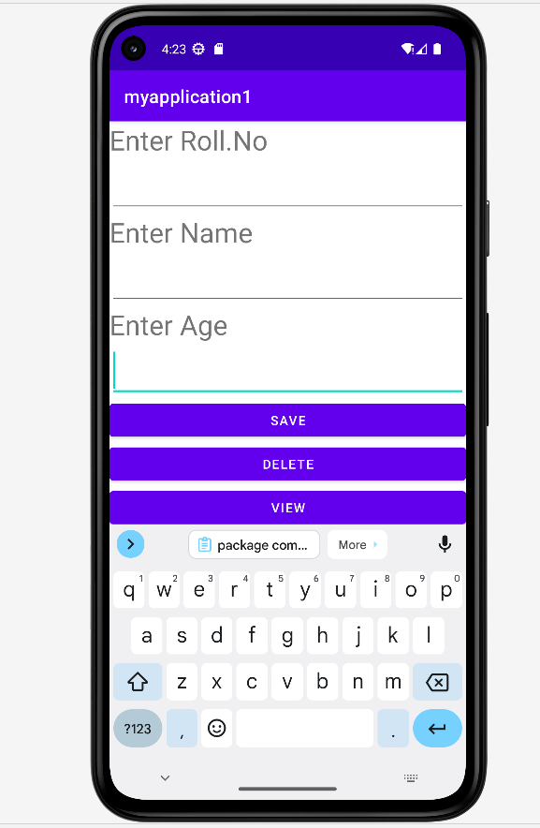

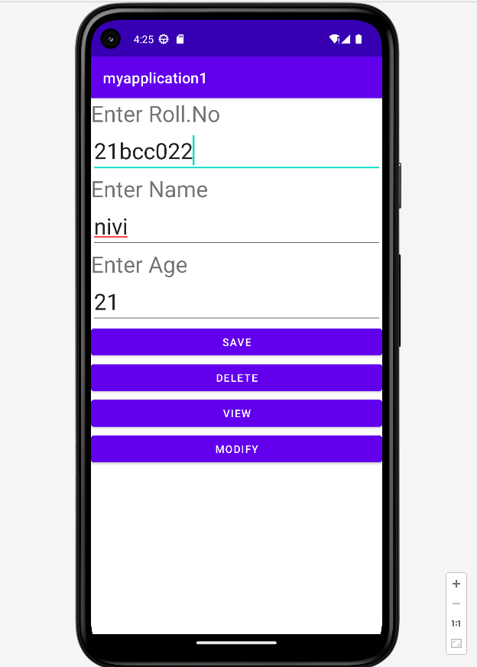

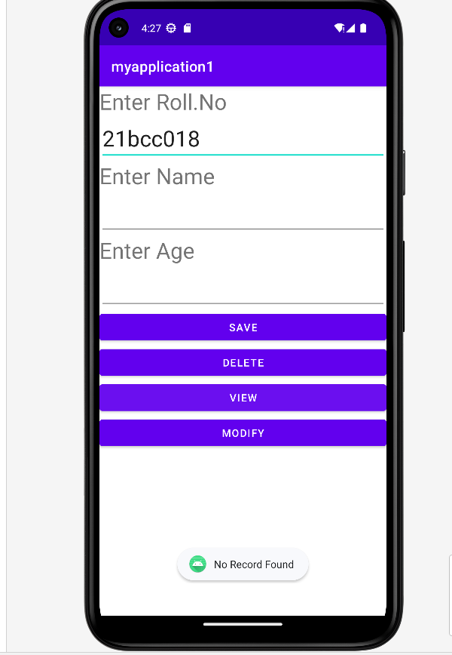

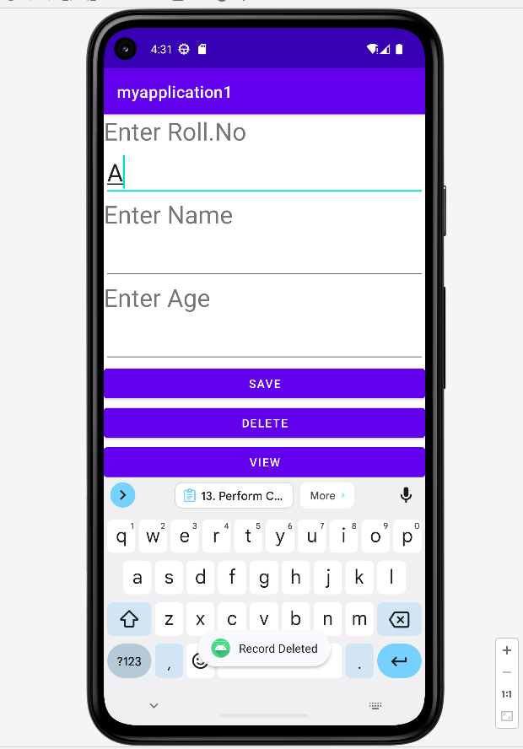

**13.CURD:**

**activity_main.xml:**

*<?*xml version="1.0" encoding="utf-8"*?>*

<RelativeLayout xmlns:android="http://schemas.android.com/apk/res/android"

xmlns:tools="http://schemas.android.com/tools"

android:layout_width="match_parent"

android:layout_height="match_parent"

android:padding="16dp"

tools:context=".MainActivity">

<EditText

android:id="@+id/edttxtname"

android:layout_width="match_parent"

android:layout_height="wrap_content"

android:hint="Name"

android:layout_marginBottom="16dp"/>

<EditText

android:id="@+id/edttxtage"

android:layout_width="match_parent"

android:layout_height="wrap_content"

android:hint="Age"

android:layout_below="@id/edttxtname"

android:layout_marginBottom="16dp"/>

<Button

android:id="@+id/btnsave"

android:layout_width="match_parent"

android:layout_height="wrap_content"

android:text="Save"

android:layout_below="@id/edttxtage"

android:layout_marginBottom="16dp"/>

<Button

android:id="@+id/btnupdate"

android:layout_width="match_parent"

android:layout_height="wrap_content"

android:text="Update"

android:layout_below="@id/btnsave"

android:layout_marginBottom="16dp"/>

<Button

android:id="@+id/btndelete"

android:layout_width="match_parent"

android:layout_height="wrap_content"

android:text="Delete"

android:layout_below="@id/btnupdate"

android:layout_marginBottom="16dp"/>

<Button

android:id="@+id/btnread"

android:layout_width="match_parent"

android:layout_height="wrap_content"

android:text="Read"

android:layout_below="@id/btndelete"

android:layout_marginBottom="16dp"/>

</RelativeLayout>

**MainActivity.java:**

package com.example.curd;

import android.annotation.SuppressLint;

import android.content.Context;

import android.database.Cursor;

import android.database.sqlite.SQLiteDatabase;

import android.os.Bundle;

import android.view.View;

import android.widget.Button;

import android.widget.EditText;

import android.widget.Toast;

import androidx.appcompat.app.AppCompatActivity;

public class MainActivity extends AppCompatActivity {

SQLiteDatabase db;

Button btnsave, btnupdate, btndelete, btnread;

EditText edttxtname, edttxtage;

@SuppressLint("MissingInflatedId")

@Override

protected void onCreate(Bundle savedInstanceState) {

super.onCreate(savedInstanceState);

setContentView(R.layout.activity_main);

btnsave = findViewById(R.id.btnsave);

btnupdate = findViewById(R.id.btnupdate);

btndelete = findViewById(R.id.btndelete);

btnread = findViewById(R.id.btnread);

edttxtname = findViewById(R.id.edttxtname);

edttxtage = findViewById(R.id.edttxtage);

db = openOrCreateDatabase("StudentDB", Context.MODE_PRIVATE, null);

db.execSQL("CREATE TABLE IF NOT EXISTS Student1(Name VARCHAR,Age VARCHAR);");

btnsave.setOnClickListener(new View.OnClickListener() {

@Override

public void onClick(View view) {

insertRecord();

}

});

btnupdate.setOnClickListener(new View.OnClickListener() {

@Override

public void onClick(View view) {

updateRecord();

}

});

btndelete.setOnClickListener(new View.OnClickListener() {

@Override

public void onClick(View view) {

deleteRecord();

}

});

btnread.setOnClickListener(new View.OnClickListener() {

@Override

public void onClick(View view) {

readRecords();

}

});

}

private void insertRecord() {

db.execSQL("INSERT INTO Student1 VALUES('"+edttxtname.getText()+"','"+ edttxtage.getText()+"');");

Toast.makeText(getApplicationContext(),"Record Inserted",Toast.LENGTH_LONG).show();

}

private void updateRecord() {

db.execSQL("UPDATE Student1 SET Age='"+edttxtage.getText()+"' WHERE Name='"+edttxtname.getText()+"';");

Toast.makeText(getApplicationContext(),"Record Updated",Toast.LENGTH_LONG).show();

}

private void deleteRecord() {

db.execSQL("DELETE FROM Student1 WHERE Name='"+edttxtname.getText()+"';");

Toast.makeText(getApplicationContext(),"Record Deleted",Toast.LENGTH_LONG).show();

}

private void readRecords() {

Cursor cursor = db.rawQuery("SELECT * FROM Student1", null);

StringBuilder stringBuilder = new StringBuilder();

if (cursor.moveToFirst()) {

do {

String name = cursor.getString(0);

String age = cursor.getString(1);

stringBuilder.append("Name: ").append(name).append(", Age: ").append(age).append("\n");

} while (cursor.moveToNext());

}

cursor.close();

Toast.makeText(getApplicationContext(), stringBuilder.toString(), Toast.LENGTH_LONG).show();

}

}

**14.SMS**

**activity_main.xml:**

*<?*xml version="1.0" encoding="utf-8"*?>*

<androidx.constraintlayout.widget.ConstraintLayout xmlns:android="<http://schemas.android.com/apk/res/android>"

xmlns:app="<http://schemas.android.com/apk/res-auto>"

xmlns:tools="<http://schemas.android.com/tools>"

android:layout_width="match_parent"

android:layout_height="match_parent"

tools:context=".MainActivity2">

<EditText

android:id="@+id/editTextPhoneNo"

android:layout_width="wrap_content"

android:layout_height="wrap_content"

android:ems="10"

android:inputType="textPersonName"

android:text="Name"

app:layout_constraintBottom_toBottomOf="parent"

app:layout_constraintEnd_toEndOf="parent"

app:layout_constraintHorizontal_bias="0.502"

app:layout_constraintStart_toStartOf="parent"

app:layout_constraintTop_toTopOf="parent"

app:layout_constraintVertical_bias="0.115"

tools:ignore="MissingConstraints" />

<EditText

android:id="@+id/editTextSMS"

android:layout_width="wrap_content"

android:layout_height="wrap_content"

android:ems="10"

android:inputType="textPersonName"

android:text="Name"

app:layout_constraintBottom_toBottomOf="parent"

app:layout_constraintEnd_toEndOf="parent"

app:layout_constraintHorizontal_bias="0.497"

app:layout_constraintStart_toStartOf="parent"

app:layout_constraintTop_toTopOf="parent"

app:layout_constraintVertical_bias="0.225"

tools:ignore="MissingConstraints" />

<Button

android:id="@+id/buttonSend"

android:layout_width="wrap_content"

android:layout_height="wrap_content"

android:text="Send"

app:layout_constraintBottom_toBottomOf="parent"

app:layout_constraintEnd_toEndOf="parent"

app:layout_constraintHorizontal_bias="0.349"

app:layout_constraintStart_toStartOf="parent"

app:layout_constraintTop_toTopOf="parent"

app:layout_constraintVertical_bias="0.383"

tools:ignore="MissingConstraints" />

<Button

android:id="@+id/btnback"

android:layout_width="wrap_content"

android:layout_height="wrap_content"

android:text="Back"

app:layout_constraintBottom_toBottomOf="parent"

app:layout_constraintEnd_toEndOf="parent"

app:layout_constraintHorizontal_bias="0.727"

app:layout_constraintStart_toStartOf="parent"

app:layout_constraintTop_toTopOf="parent"

app:layout_constraintVertical_bias="0.383"

tools:ignore="MissingConstraints" />

</androidx.constraintlayout.widget.ConstraintLayout>

**MainActivity.java:**

package com.example.myapplication1;

import androidx.appcompat.app.AppCompatActivity;

import android.os.Bundle;

import android.content.Intent;

import android.net.Uri;

import android.view.View;

import android.widget.Button;

import android.widget.EditText;

import android.widget.Toast;

public class MainActivity2 extends AppCompatActivity {

Button buttonSend,btnback;

EditText textPhoneNo,textSMS;

@Override

protected void onCreate(Bundle savedInstanceState) {

super.onCreate(savedInstanceState);

setContentView(R.layout.*activity_main2*);

buttonSend = (Button) findViewById(R.id.*buttonSend*);

textPhoneNo = (EditText) findViewById(R.id.*editTextPhoneNo*);

textSMS = (EditText) findViewById(R.id.*editTextSMS*);

buttonSend.setOnClickListener(new View.OnClickListener() {

@Override

public void onClick(View v) {

String phoneNo = textPhoneNo.getText().toString();

String sms = textSMS.getText().toString();

try {

*// SmsManager smsManager = SmsManager.getDefault();*

*// smsManager.sendTextMessage(phoneNo, null, sms, null, null);*

Intent in = new Intent(Intent.*ACTION_VIEW*, Uri.*parse*( "sms:" + phoneNo ) );

in.putExtra( "sms_body", sms );

startActivity(in);

Toast.*makeText*(getApplicationContext(), "SMS Sent!", Toast.*LENGTH_LONG*).show();

} catch (Exception e) {

Toast.*makeText*(getApplicationContext(),e.getMessage(),Toast.*LENGTH_LONG*).show();

}

}

});

btnback=(Button)findViewById(R.id.*btnback*);

btnback.setOnClickListener(new View.OnClickListener() {

@Override

public void onClick(View v) {

Intent i1=new Intent(MainActivity2.this,MainActivity.class);

startActivity(i1);

}

});

}

}

**Androidmanifest.xml**

before the application tag opening

<uses-permission android:name="android.permission.SEND_SMS"/>

<uses-permission android:name="android.permission.RECEIVE_SMS"/>